Software Design Document
Student Result Management System



Submitted by
Syed Muhammad Shahzil (S23BINFT1M01067)

Submitted to
Dr. Syed Ali Nawaz Shah

Department of Information Technology
Faculty of Computing
The Islamia University of Bahawalpur

Summary
The Student Result Management System (SRMS) is designed to modernize and streamline the management of academic results within educational institutions. The system addresses the limitations of manual result processing by providing an efficient, secure, and user-friendly platform for recording, processing, storing, and accessing student academic records. It enhances accuracy, transparency, and accessibility, enabling students, faculty members, administrators, and parents to interact with academic information more effectively while ensuring data integrity and confidentiality.
The system is developed using an Agile and Iterative Development approach, allowing continuous improvement and adaptability to evolving educational requirements. The design follows Object-Oriented Design (OOD) principles and utilizes Unified Modeling Language (UML) models, including class diagrams and sequence diagrams, to ensure a structured, maintainable, and scalable solution. A multi-tier architecture is implemented, consisting of presentation, business logic, and data layers, which ensures separation of concerns, improved performance, and enhanced system scalability.
Core functionalities of the SRMS include user authentication, result processing, grade calculation, academic record management, data retrieval, reporting, analytics, and role-based access control for students, faculty, and administrators. The system uses a secure relational database to manage student, course, result, user, and configuration data while maintaining confidentiality and data integrity. In addition, reporting and analytical features provide valuable insights into student performance and academic trends, supporting informed decision-making by educators and administrators.
The system is implemented using PHP, SQL, HTML, CSS, and JavaScript, with REST APIs enabling efficient communication between system components. Security is strengthened through SSL encryption and LDAP-based authentication mechanisms. Quality assurance is supported through testing tools such as Selenium and Apache JMeter, ensuring reliability, performance, and usability. Furthermore, the system provides CSV and PDF export functionality to support reporting and record management.

Table of Content
- Application Architecture…………………………………………………………
1.1 Architectural Design………………………………………………………………………………………..
1.2 Process Flow / Representation…………………………………………………………………………
1.3 Design Models…………………………………………………………………………………………………
Class Diagram……………………………………………………………………………………………………
Sequence Diagram…………………………………………………………………………………………….
State Transition Diagram……………………………………………………………………………………
Data Flow Diagram……………………………………………………………………………………………
Schematic Diagram (Hardware Projects Only)…………………………………………………..
Timing Diagram (Hardware Projects Only)………………………………………………………..
Data Design ……………………………………………………………………………………………………
- Data Model Schema……………………………………………………………………………….
2.1 Student Entity………………………………………………………………………………………………..
2.2 Course Entity………………………………………………………………………………………………….
2.3 Result Entity…………………………………………………………………………………………………..
2.4 User Entity (Role-Based Access Control - RBAC)……………………………………………..
2.5 System Configuration Entity…………………………………………………………………………..
2.6 Overall Relationship Summary…………………………………………………………………………
- User Interface (Human Interface Design / HCI)
Screen Images……………………………………………………………………………………………..
Server Image……………………………………………………………………………………………….
Home Screen Images……………………………………………………………………………………
Screen Objects and Actions………………………………………………………………………….

- Application Architecture

1.1 Architectural design

The architectural design of the Student Result Management System (SRMS) is structured to provide a robust, scalable, and modular solution for effective result management within educational institutions. Following the principles of Object-Oriented Design, the architecture is organized into key modules, each encapsulating specific functionalities.

The system is designed to be distributed, with a multi-tier architecture to ensure separation of concerns and enhance scalability. The presentation layer incorporates an intuitive user interface accessible to students, parents, and faculty members, facilitating easy interaction with the system.

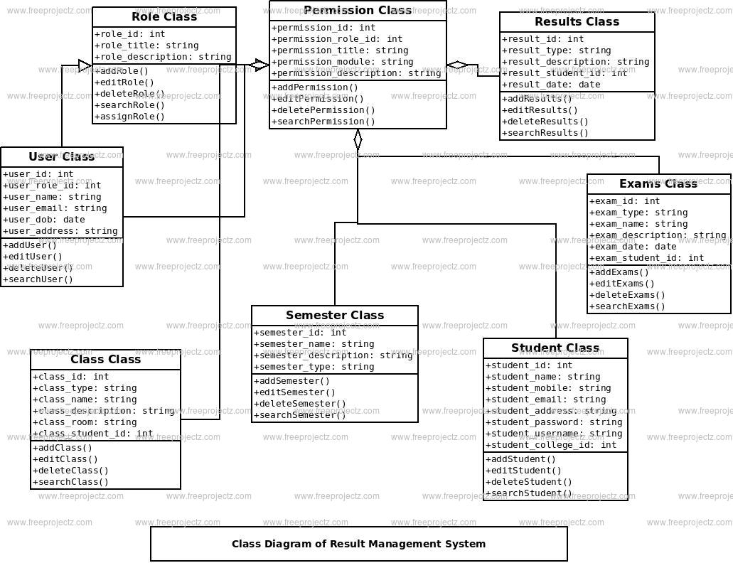

The business logic layer manages result processing, grading, and record-keeping, implementing Object-Oriented Design principles to promote code reusability and maintainability. The data layer utilizes a secure and relational database system to store and retrieve academic records, ensuring data integrity and confidentiality. Integration with third-party authentication services enhances security.

Overall, this architectural design aims to provide a flexible, scalable, and secure foundation for the SRMS, aligning with modern software engineering best practices.

1.2 Process flow/Representation

The process flow of the Student Result Management System (SRMS) is designed to efficiently handle the generation, storage, and accessibility of academic results within educational institutions.
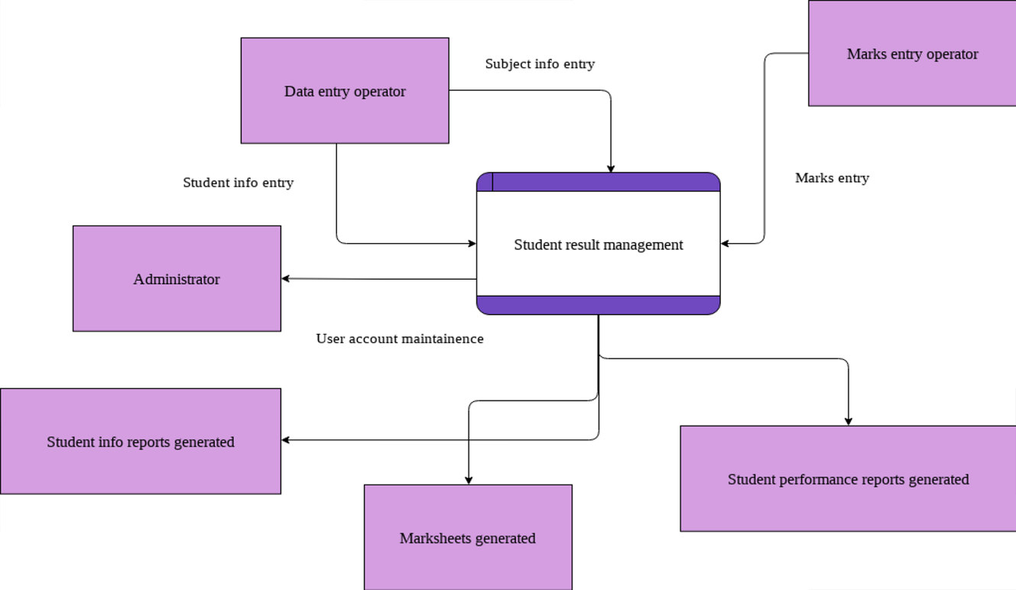

The process begins with the submission of assessment data, where educators input grades and evaluation information into the system. The system then processes this data through the grading and calculation modules, adhering to the principles of Object-Oriented Design, to ensure accuracy and consistency.

1.3 Design models

The applicable models may include:
- Class Diagram
- Sequence Diagram
- State Transition Diagram
- Data Flow Diagram
- Schematic diagram (Hardware projects only)
- Timing diagram

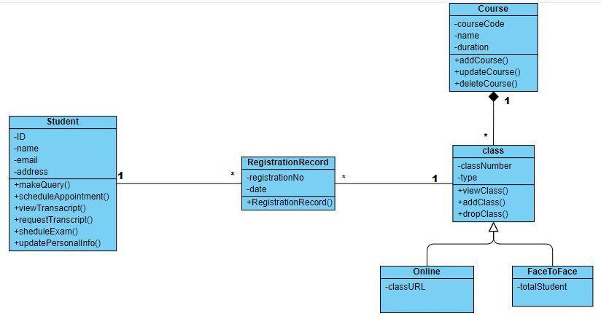
Class Diagram
.
The Student Result Management System (SRMS) class diagram comprises three fundamental classes: the Student class, representing individual students with attributes such as studentID and methods like viewResults();
the Course class, encapsulating course information with attributes like courseCode and methods like calculateFinalGrade(); and the ResultProcessor class, responsible for managing the results database and grading algorithms with methods such as processResults() and generateTranscript().
This simplified depiction captures the core entities and interactions within the SRMS, illustrating the relationships between students, courses, and the result processing system.

Sequence Diagram
The sequence diagram for the SRMS illustrates the dynamic interactions between key components during the process of generating and viewing academic results. Initiated by a student's request to view results, the sequence diagram captures the sequential flow of actions, involving the Student class.
ResultProcessor class, and the database. The Student class sends a request to the ResultProcessor, which in turn interacts with the database to retrieve the student's academic records. The ResultProcessor then processes the data, utilizing grading algorithms if necessary, and returns the results to the Student class for display.
This sequence diagram provides a concise overview of the collaboration between system components, highlighting the dynamic nature of the SRMS during result retrieval and presentation.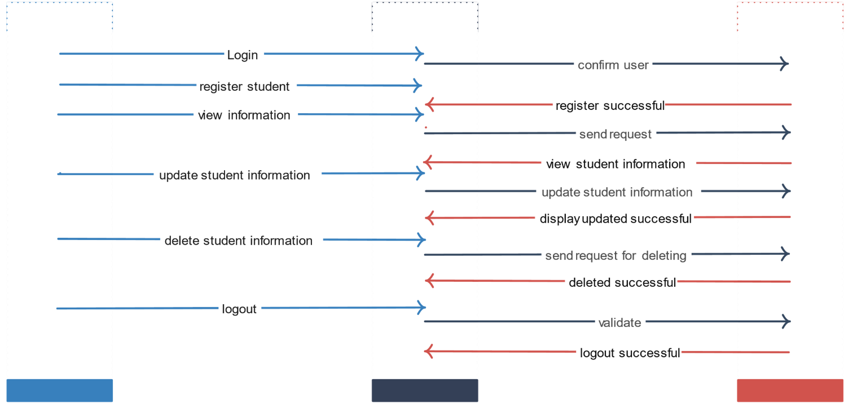

State Transition Diagram Data Flow Diagram

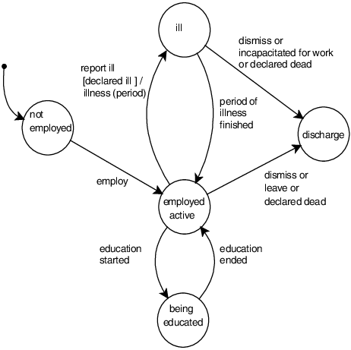

Schematic diagram (Hardware projects only)
Use lines and symbols to illustrate the connections between components, adhering to standard symbols for resistors, capacitors, and other electronic elements.
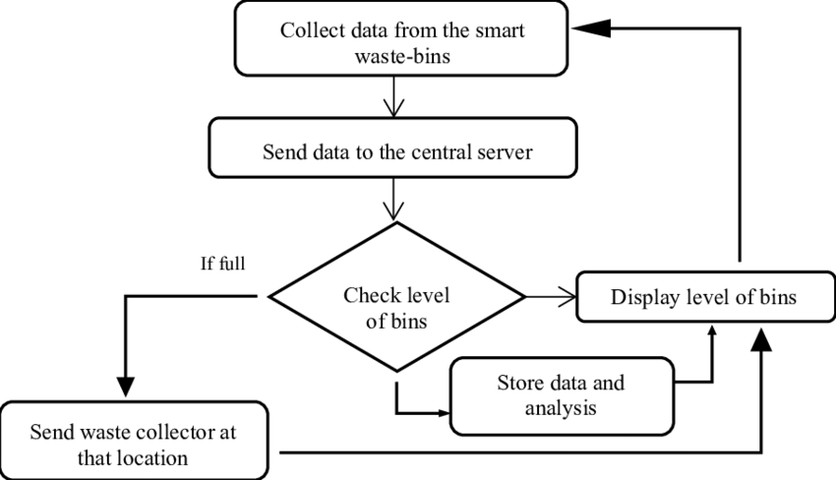

Timing diagram (Hardware projects only)
Creating a timing diagram for a hardware project involves illustrating the timing relationships between different signals or events within the system. Since I can't create visual diagrams, I'll describe how you might represent a timing diagram for a School Result Management System (SRMS) with hardware components:

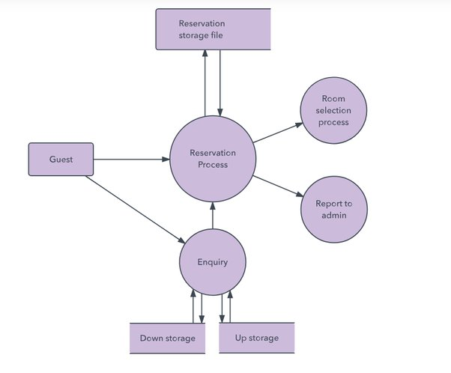

Data design
Explain how the information domain of your system is transformed into data structures. Describe how the major data or system entities are stored, processed and organized.
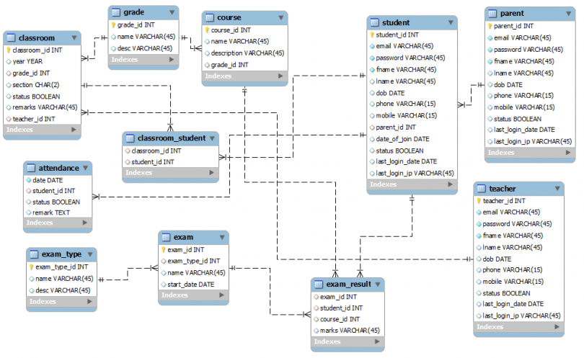

- Data Model Schema
The data model of the Student Result Management System (SRMS) is designed to efficiently store, manage, and process academic data including students, courses, results, users, and system configurations. The system follows a relational database structure where entities are interconnected through well-defined relationships to ensure data integrity, consistency, and scalability.
2.1 Student Entity
The Student entity represents individuals enrolled in the educational institution and acts as the primary actor for academic result access. It stores personal and academic enrollment information required for result processing and reporting.
Attributes:
- StudentID (Primary Key)
- FirstName
- LastName
- Email
- Class / Section
- EnrolledCourses

Working Properties:

The Student entity is used to uniquely identify each student in the system. It allows students to authenticate, access their academic results, and view course-wise performance. The entity also supports linkage with result records and course enrollment data, ensuring that each academic record is correctly mapped to the respective student.
Relationships:
Student (1) → (M) Result
One student can have multiple result records.
Student (M) ↔ (M) Course
Students can enroll in multiple courses (handled through Result entity or enrollment mapping).
2.2 Course Entity

The Course entity represents academic subjects offered by the institution. It defines course structure and is used in grading and result calculation processes.

Attributes:
- CourseCode (Primary Key)
- CourseName
- Credits
- EnrolledStudents
Working Properties:

The Course entity manages all academic courses within the system. It provides the structure for grade calculation and ensures that each course is associated with multiple students. It is used by the ResultProcessor module for computing final grades and generating academic reports.

Relationships:
- Course (1) → (M) Result
One course can have multiple result entries for different students.
- Course (M) ↔ (M) Student
Many students can enroll in many courses.

2.3 Result Entity

The Result entity is the core transactional entity of the SRMS, responsible for storing student performance data for each course.

Attributes:
- ResultID (Primary Key)
- StudentID (Foreign Key)
- CourseCode (Foreign Key)
- Grade
- Marks (if applicable)
Working Properties:

The Result entity acts as a bridge between Student and Course entities. It stores academic performance data such as grades and marks. It is processed by the ResultProcessor module, which applies grading logic and generates transcripts. This entity ensures accurate and structured storage of academic outcomes.

Relationships:
- Result (M) → (1) Student
- Result (M) → (1) Course
Acts as a bridge entity (junction table) between Student and Course.
2.4 User Entity (RBAC – Role Based Access Control)

The User entity manages system authentication and role-based access for different system users including students, faculty, and administrators.

Attributes:
- UserID (Primary Key)
- Username
- Password
- Role (Student / Teacher / Admin / Parent)
Working Properties:

The User entity is responsible for system security and authentication. It ensures that only authorized users can access specific modules of the SRMS. Role-based access control (RBAC) is implemented to restrict or allow access depending on the user type.

Relationships:
- User (1) → (1) Student (for student role mapping)
- User (1) → (1) Faculty/Admin Profile (if applicable)
Controls access to Result and Course modules based on role.

2.5 System Configuration Entity

The System Configuration entity stores system-level settings and parameters that control system behavior.

Attributes:
- ConfigID (Primary Key)
- Parameter
- Value
Working Properties:

This entity manages global system settings such as grading scale, academic session configuration, and system preferences. It allows administrators to dynamically adjust system behavior without modifying source code.

Relationships:
- Independent entity
- Accessed by Admin/User roles for configuration management
2.6 Overall Relationship Summary

The SRMS data model follows these main relationships:

Student (1) → (M) Result
Course (1) → (M) Result
Result (M) → (1) Student
Result (M) → (1) Course
User controls access to all entities through Role-Based Access Control
System Configuration remains independent but supports system-wide settings

ER Diagram

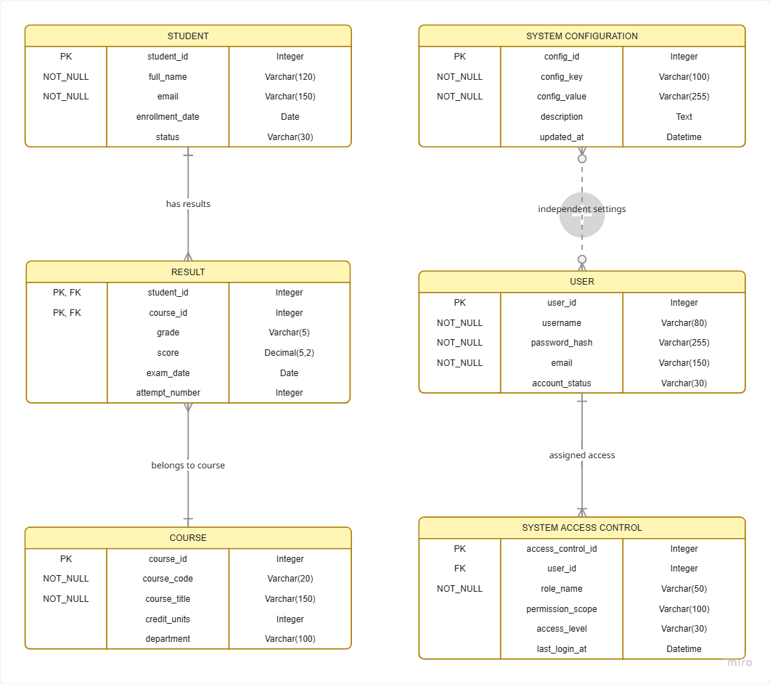

- User Interface
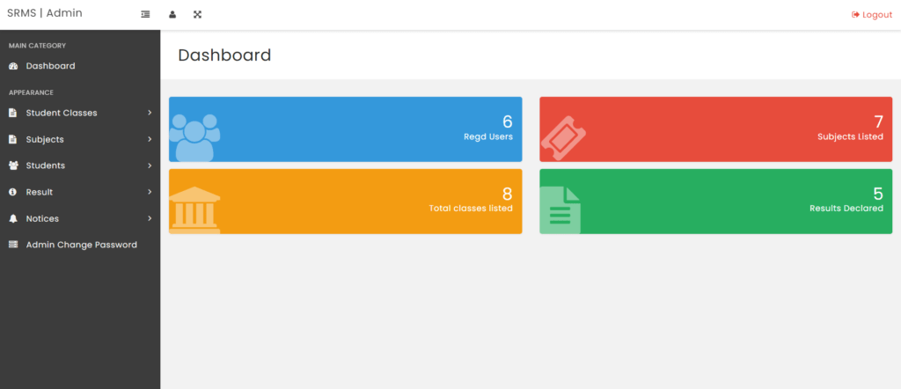
Human Interface Design, also known as Human-Computer Interaction (HCI) design, focuses on creating user interfaces that are intuitive, efficient, and enjoyable for users. In the context of a Student Result Management System(SRMS), an effective human interface design is crucial for ensuring that users, including students, faculty, and administrators, can interact with the system seamlessly. Here are key considerations and principles for human interface design in an SRMS

Screen images

The screen images for the Student Result Management System (SRMS) are meticulously designed to optimize user experience and functionality. The dashboard provides an insightful overview of recent results and upcoming events through widgets and charts. Result viewing screens offer students a clear and organized presentation of their academic performance, including individual course grades, cumulative GPA, and feedback. The course registration interface facilitates easy navigation with a course list, descriptions, and intuitive filters.

1: Server image
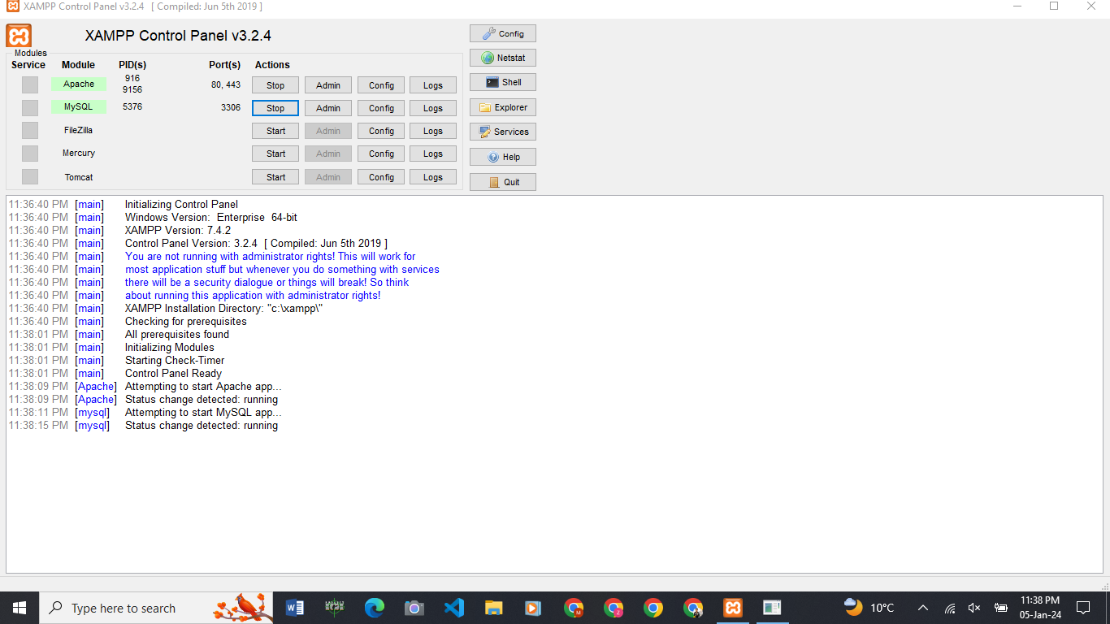

2: Home image
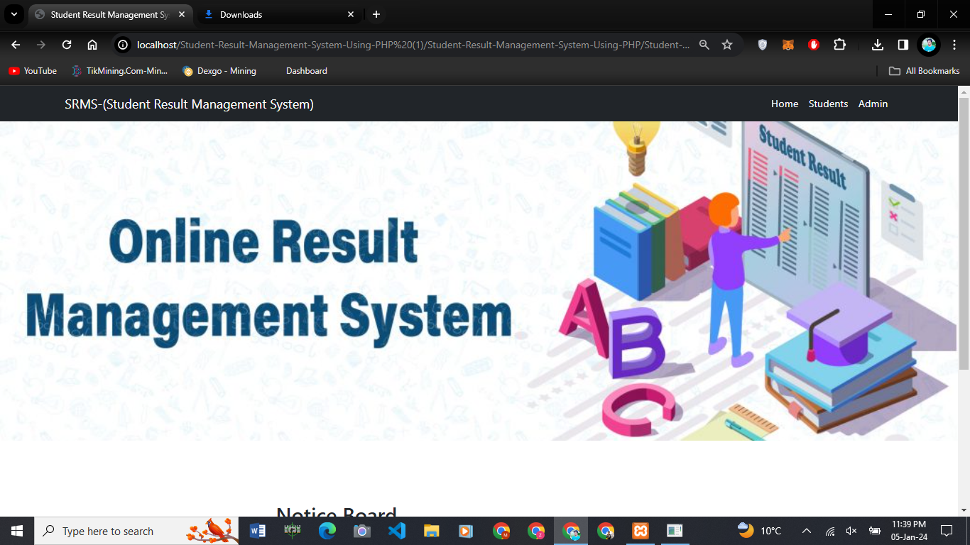

Screen objects and actions
The screen discussion outlines the various objects presented on the result viewing screen and the actions users can perform. The design ensures a comprehensive representation of academic results, providing a user-friendly and informative experience for students interacting with the SRMS. Similar discussions can be conducted for other screens within the system, tailoring the objects and actions to the specific functionalities they represent.
Display essential student details such as name, student ID, and enrollment information. Course Cards: Each course is represented by a card containing the course name, code, and the corresponding grade achieved by the student.

